

**NESD-QA: Automation Configuration Guide**

Document Revision # : Version 1.0

Data classification : C2

Document Owner: Pheta Moloi  
Approved By:   
 09 February 2023

**APPROVAL**

|  |  |  |  |  |
| --- | --- | --- | --- | --- |
| Name | Designation | Company | Date | Signature |
| Pheta Moloi | Senior Specialist : NESD-QA | Vodacom |  |  |
| Nthabiseng Mokoena | Specialist : NESD-QA | Vodacom |  |  |

**CONTRIBUTORS**

|  |  |  |
| --- | --- | --- |
| Name | Designation | Company |
| Masiza Qutu | Manager : NESD-QA |  |
| Nthabiseng Mokoena | Specialist : NESD-QA |  |
| Thandi Khoza | Specialist : NESD-QA |  |
| Phikolomzi Genge | Specialist : NESD-QA |  |
| Nare Mathatho | Specialist : NESD-QA |  |
| Wilheminah Ngqola | Specialist : NESD-QA |  |
| Hilary Steyn | Specialist : NESD-QA |  |
| Dineo Moloi | Specialist : NESD-QA |  |
|  |  |  |

**DOCUMENT HISTORY**

|  |  |  |  |
| --- | --- | --- | --- |
| Revision | Name | Date | Comments |
| 1.0 | Pheta Moloi | 09 February 2023 | Initial draft |

# Introduction

## Purpose

The document is intended to detail the setup and configuration of the automation framework.

The intended audience of the document is the NESD-QA team, and any senior leaders whose support is needed to carry out communication plans.

# Framework Architecture

The framework is based on the behaviour-driven development methodology (BDD). ALM octane is used for test case management and the development of the Gherkin scripts.

This is hybrid framework which is designed to accommodate Selenium for any web-based type of testing and API automation testing.

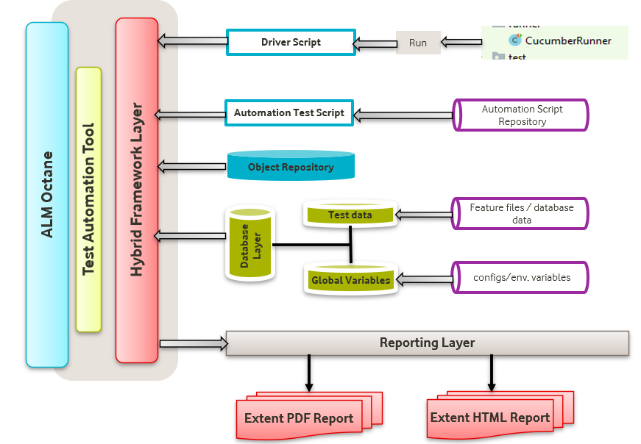

# Testing Process

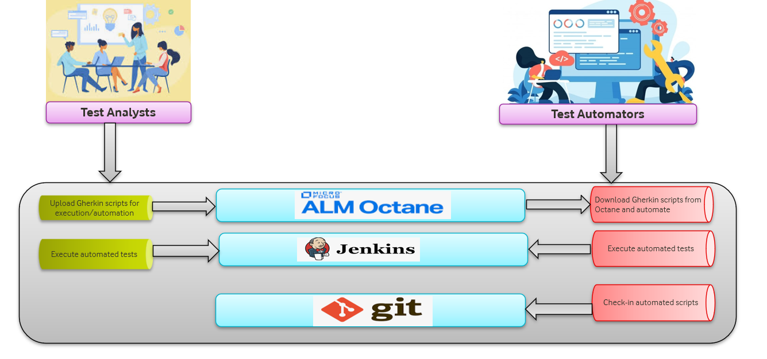

**Test Analysts**

* Based on the requirements, use ALM Octane to capture test cases in a form of gherkin scripts.
* Update/inform Test Automators on any new required function which may not have been automated.
* Download gherkin scripts from Octane and use Jenkins to execute gherkin scripts / feature files.
* Analyse the generated test report for any issues before distribution.

**Test Automators**

* Download from Octane any of the test which require automation and utilise the defined IDE and automation process to automate the required function/requirement.
* Update GIT with up to date and newly automated functions.

# Test Environments

Users will be required to have access to:

* ALM Octane

Request to ALM Octane administrator(s) for access

Octane url: <http://10.114.222.150:8080/ui/>

* Jenkins

Request for access to Jenkins will sent to Jenkins administrator(s). This is administered from the automation team.

Jenkins url: <http://qeng103zatpwi:8080/>

* Execution server

User will have to log a call via [whitepages](https://whitepages.sso.vodacom.co.za/) for access to the execution server.

Whitepages resource should be [**NESDQA_Test_OS_WI**](https://whitepages.sso.vodacom.co.za/idmdash/)

# Test Environment setup

Once access to ARM Resource([**NESDQA_Test_OS_WI**](https://whitepages.sso.vodacom.co.za/idmdash/)) is approved, you will be allowed access to the execution server “qeng103zatpwi”.

It is mainly recommended to **map a network** drive to **qeng103zatpwi** in to have access to your working directory.

Use your Vodacom domain credentials to login to the server, \\qeng103zatpwi\C$\executions

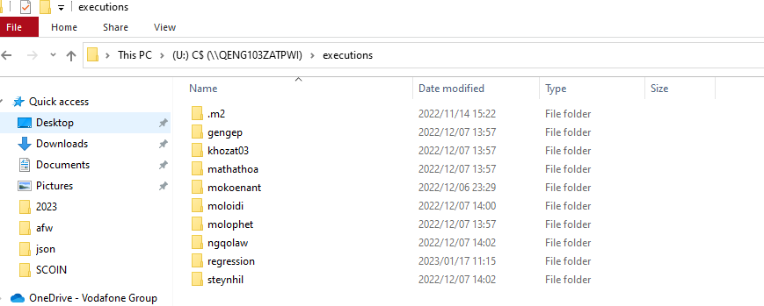

# Test Execution

This is assuming all necessary access has been granted one to execute their test cases, all gherkin test(s) are added in ALM Octane in accordance with SDQA Testing processes.

1. Download gherkin tests from ALM Octane

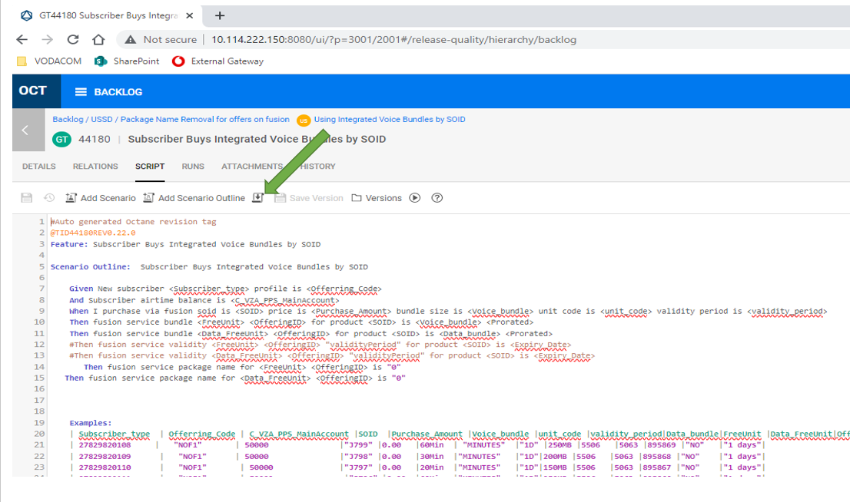

1. Save/Copy gherkin tests to \\qeng103zatpwi\C$\executions\{usename}\featureRunner, where {username} is directory of the user executing at the time.

E.g. \\qeng103zatpwi\C$\executions\molophet\featureRunner would mean that the user whose username name is “molophet” will be executing the test.

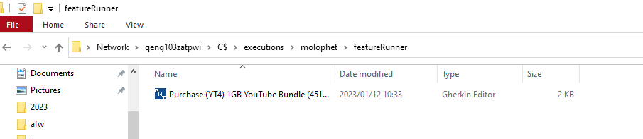

1. Using your favourite browser, login to the Jenkins <http://qeng103zatpwi:8080/>.
   * Select the folder you belong to. {Analysts or Automation}

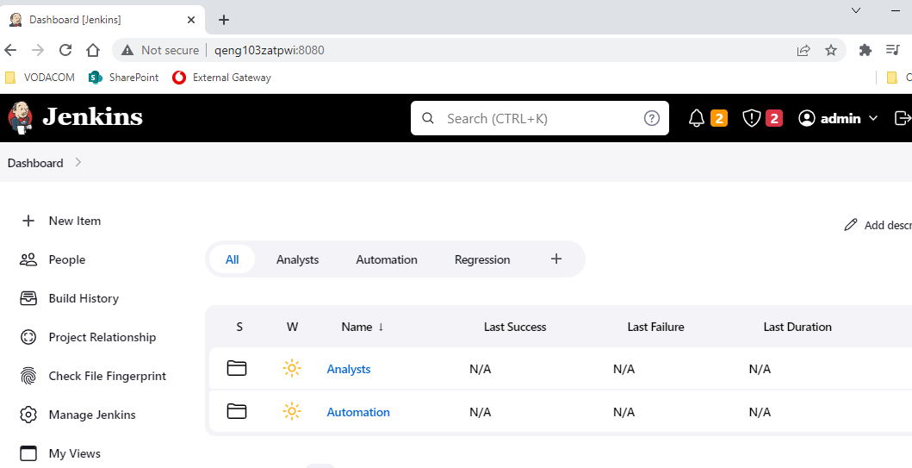

* + Select the appropriate Jenkins job according to your name.

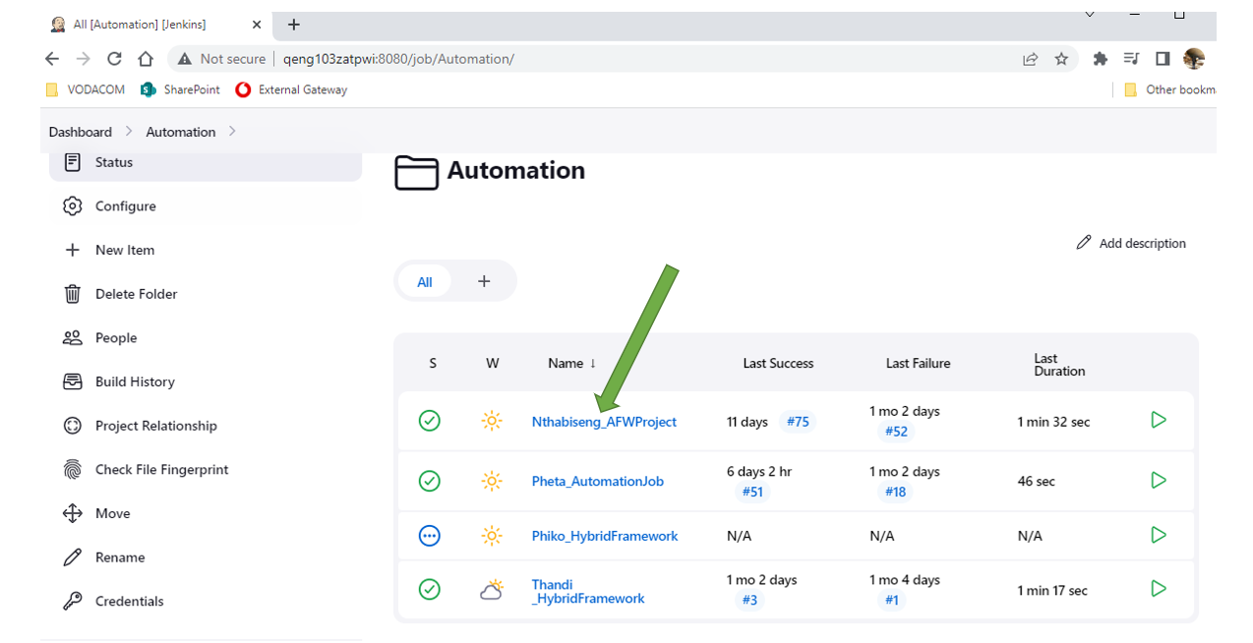

* + Click on “Build Now” to begin test execution.

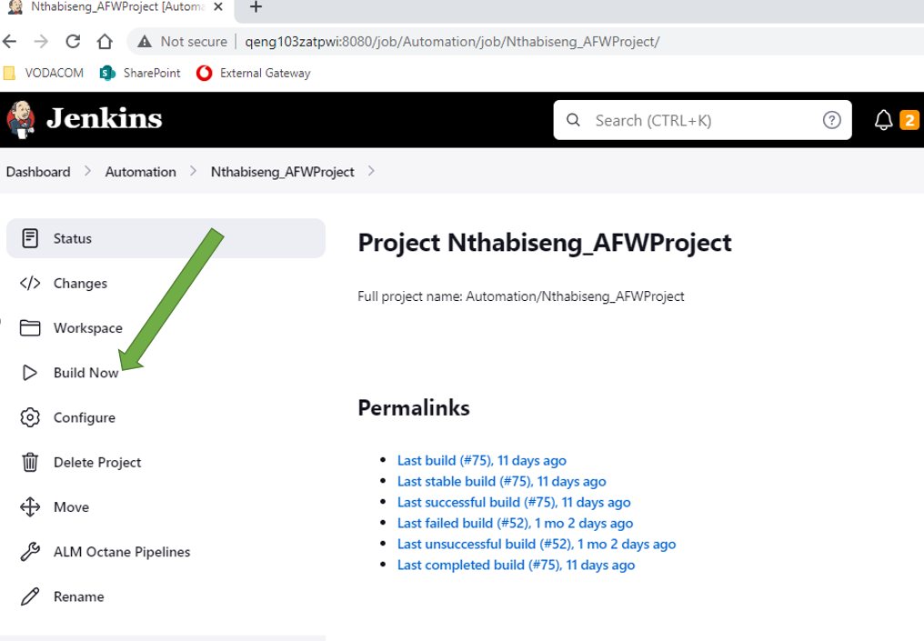

1. When the test is complete, test report will automatically be generated and saved to \\qeng103zatpwi\C$\executions\{username}\Reports. Please take note that reports will be saved in a with the naming convention “Reports dd-mm-yy h-m-s”

